I hosted this website in two web hosting site in case one of this hosting is down since they are free webhost

Open the Browser and search any

[***http://nkanyisom123.byethost3.com/***](http://nkanyisom123.byethost3.com/)

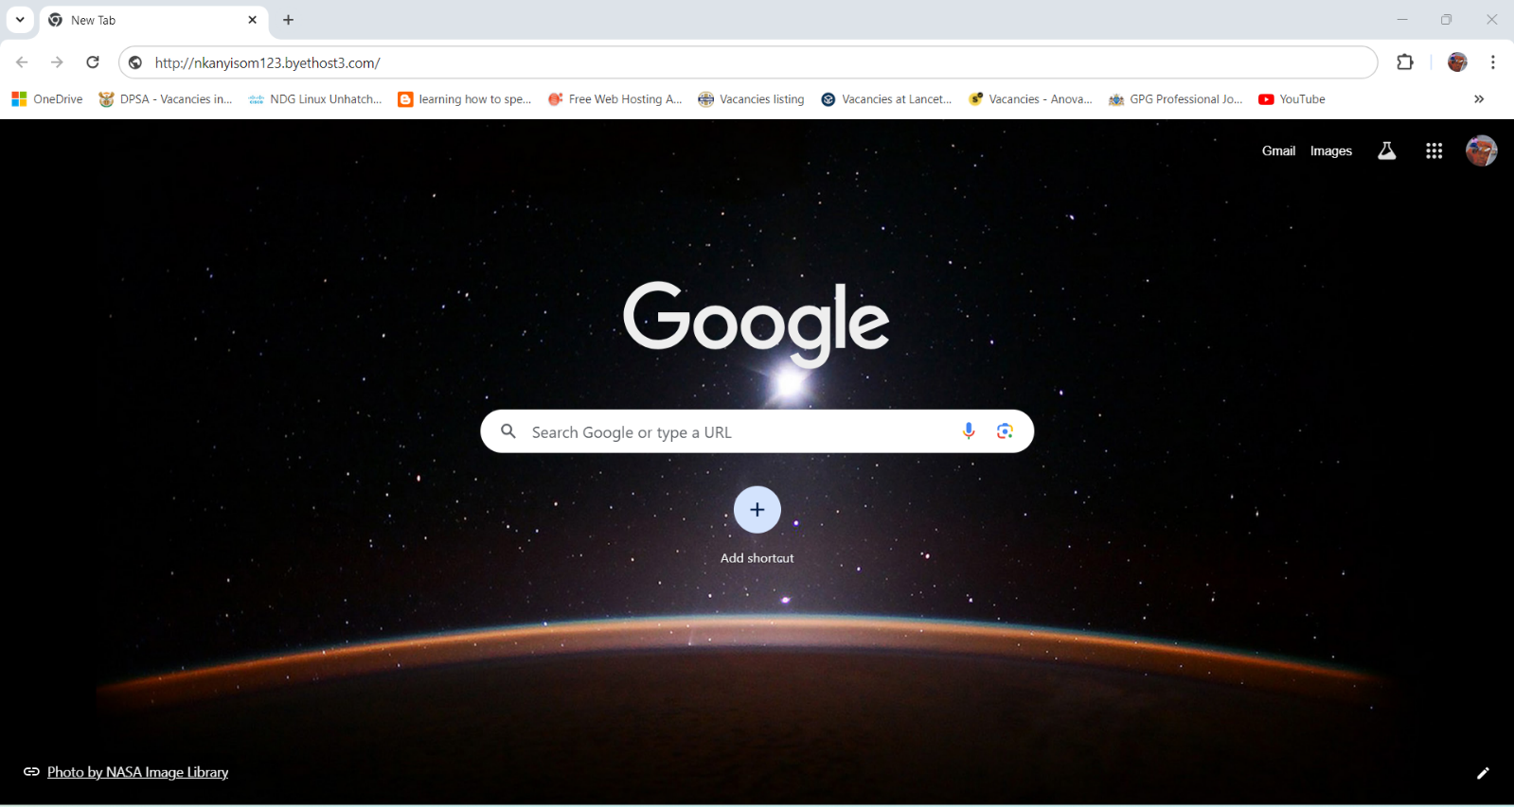

[***http://nkanyiso-m.000webhostapp.com***](http://nkanyiso-m.000webhostapp.com)

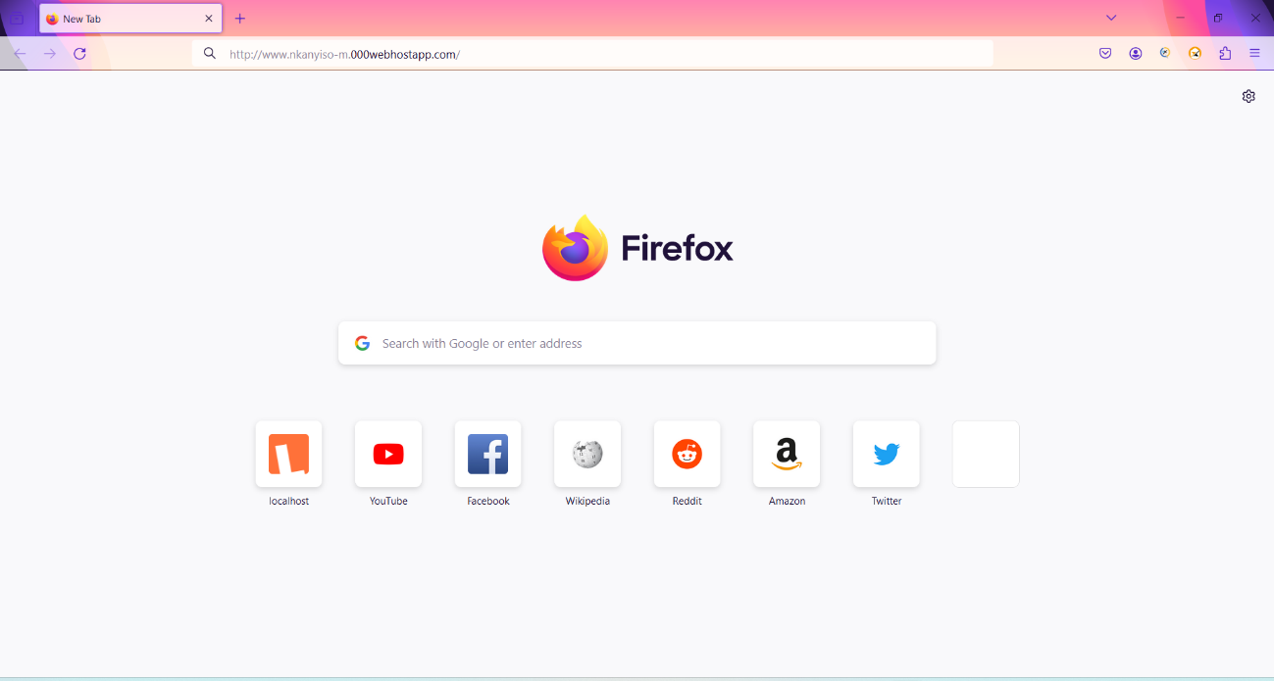

The below website will be displayed

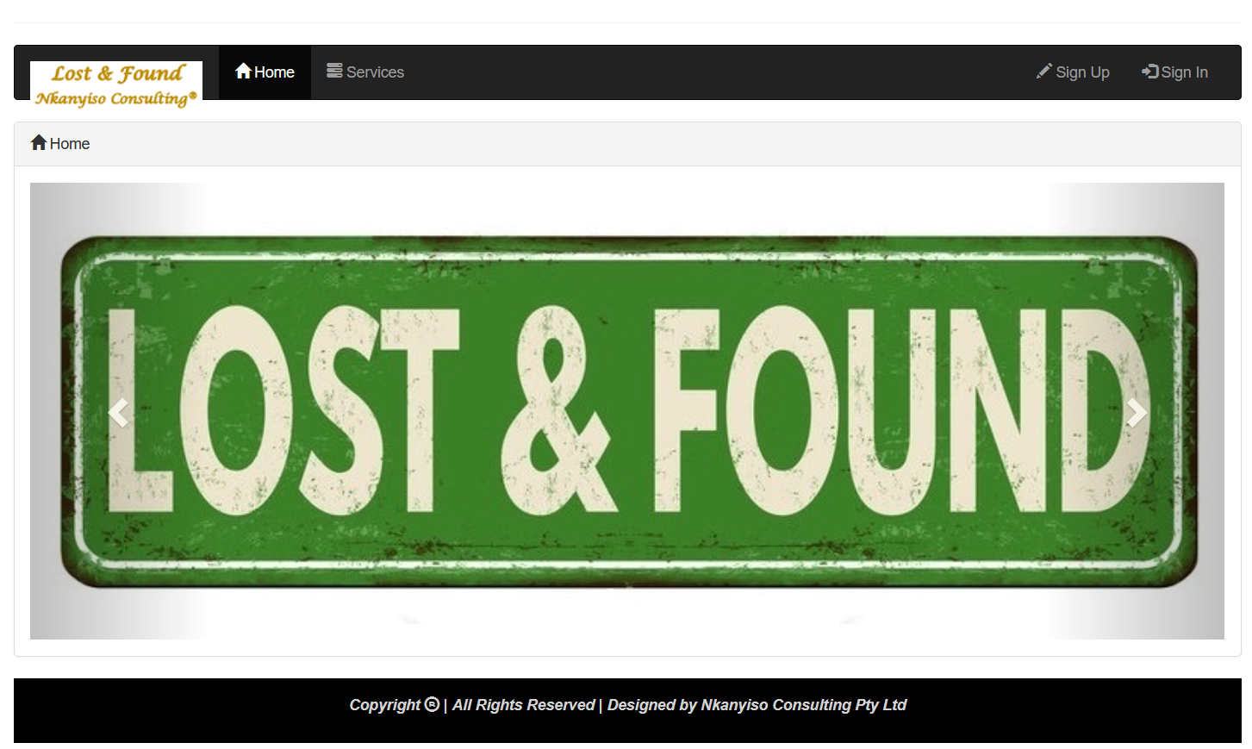

Just ***Sign-Up*** if you do not have an account yet and wait for Admin to approve your account

or ***Sign-In*** if you already have done so.

*Sign-In* as a **Student**

Once ***Sign-In*** as a Student the below page will be displayed, showing ***Navigation tabs*** to different pages

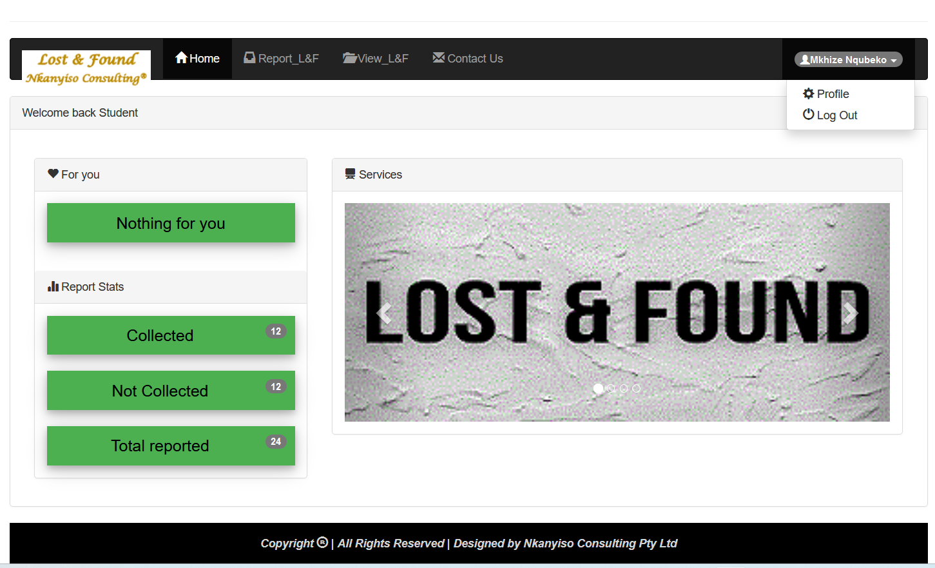

On the **Report_L&F** tab is where you can type the Identifier (*Student Number*) of the found document

and select the ***type of that document***, then below there you **select where the owner can come and collect it** once done everything you can Press **Submit** Button

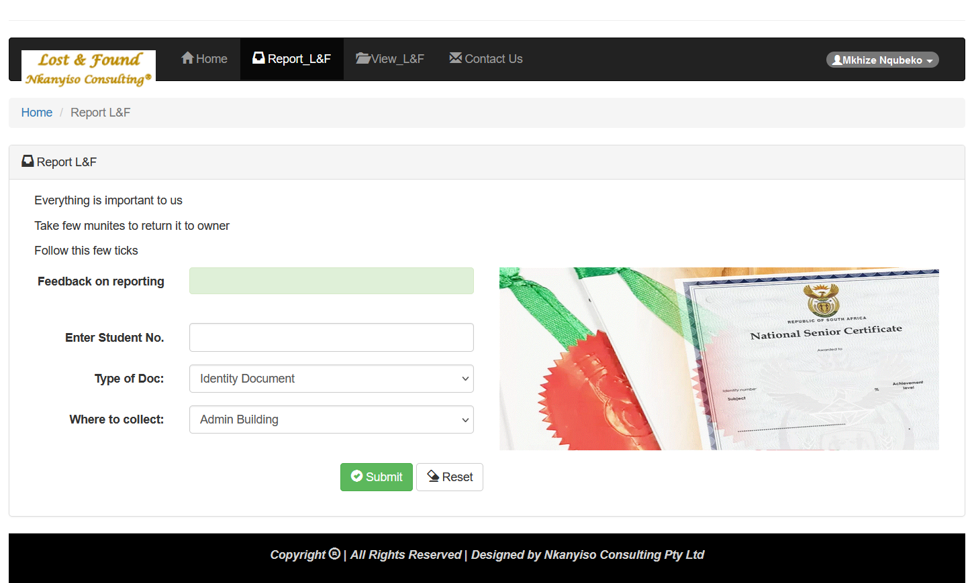

On the **View_L&F** tab is where you can view information about documents that

have been reported and also see the status of each document **Collected, !Collected**

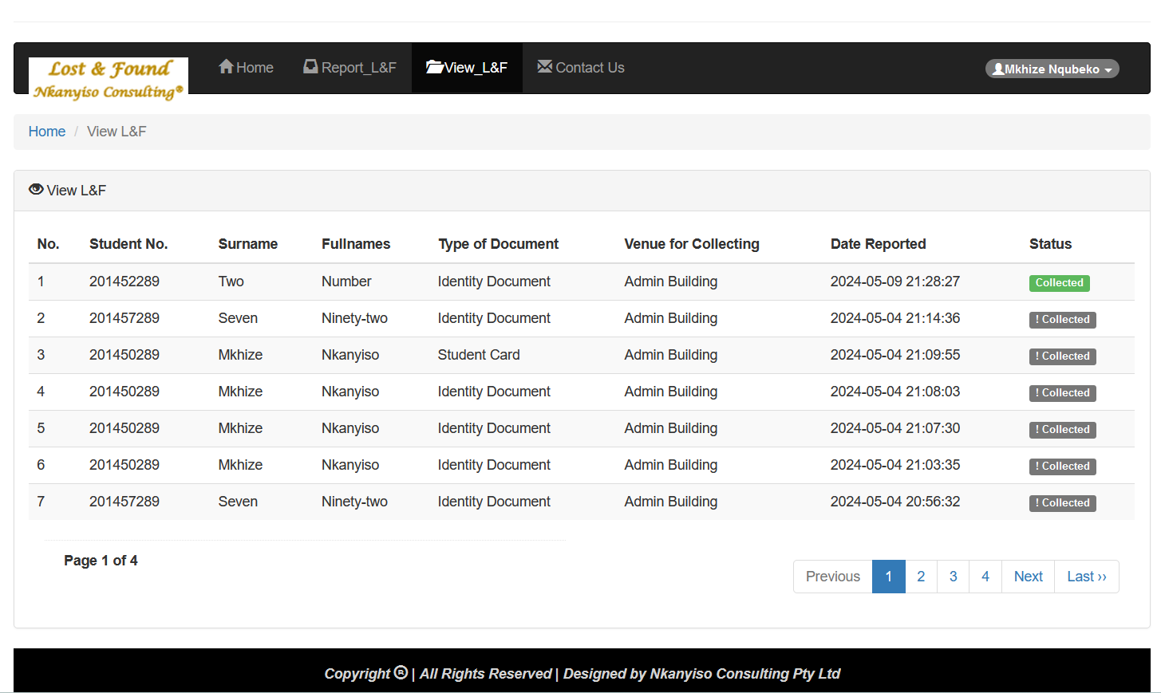

On the **Contact Us** tab is where you can send us a messages

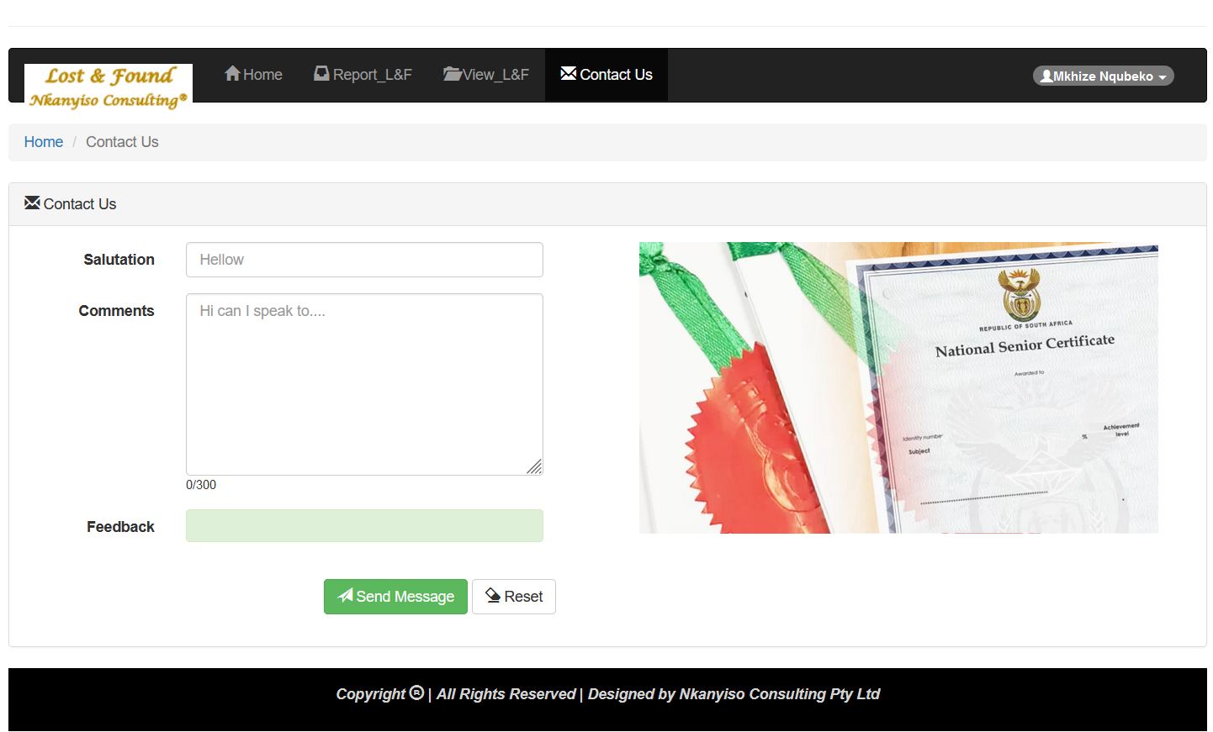

On the **Username** you find a dropdown arrow where you can find **Profile** to update the information about yourself, including changing the default password to a more secured one. And also **Log Out** button

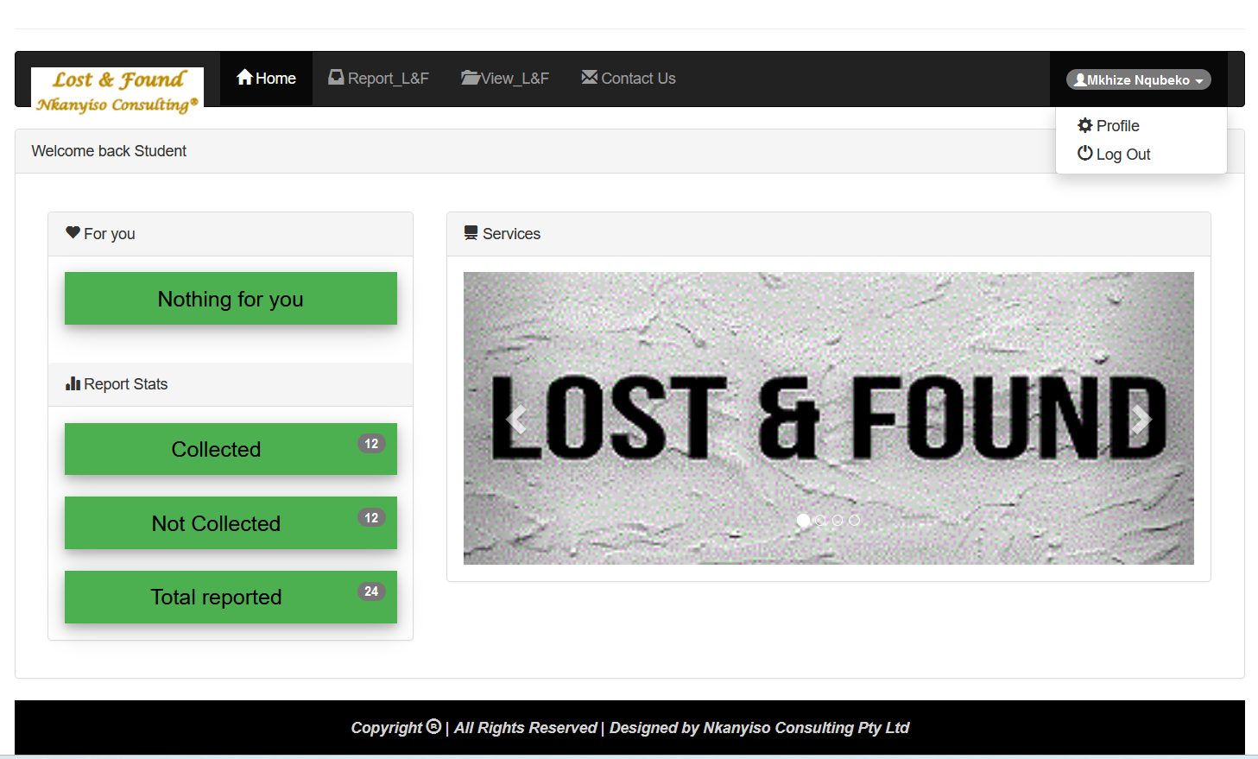

*Sign-In* as a **Admin**

Once ***Sign-In*** as a Student the below page will be displayed, showing ***Navigation tabs*** to different pages

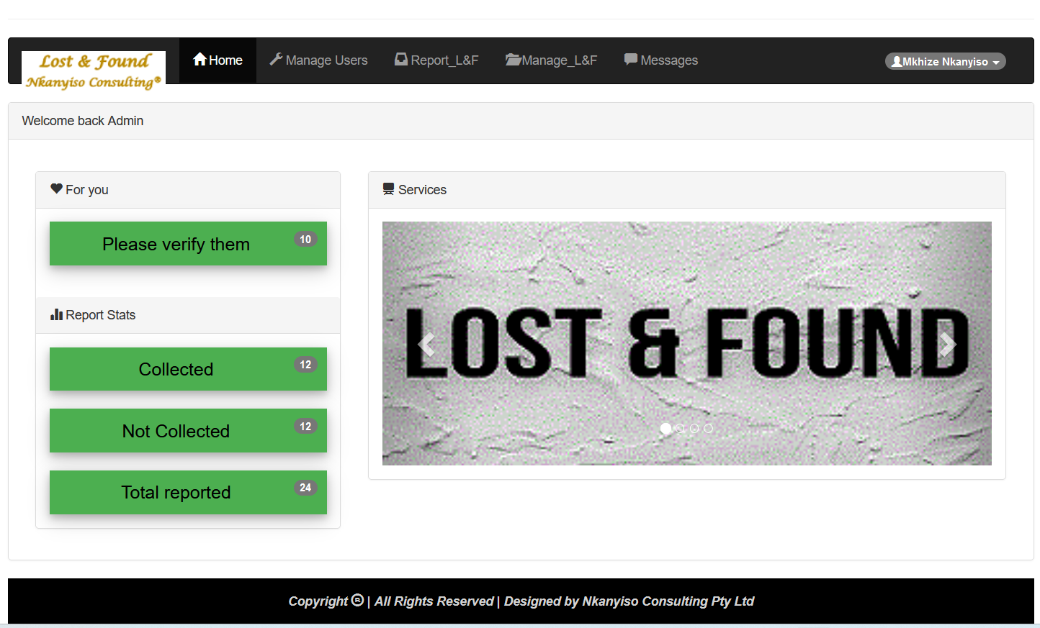

On the **Manage Users** tab is where you can view information about registered users, as Admin you can **Approve** Users**, Remove** Users**, Reset** *Users* **Password** and also **Delete** Users

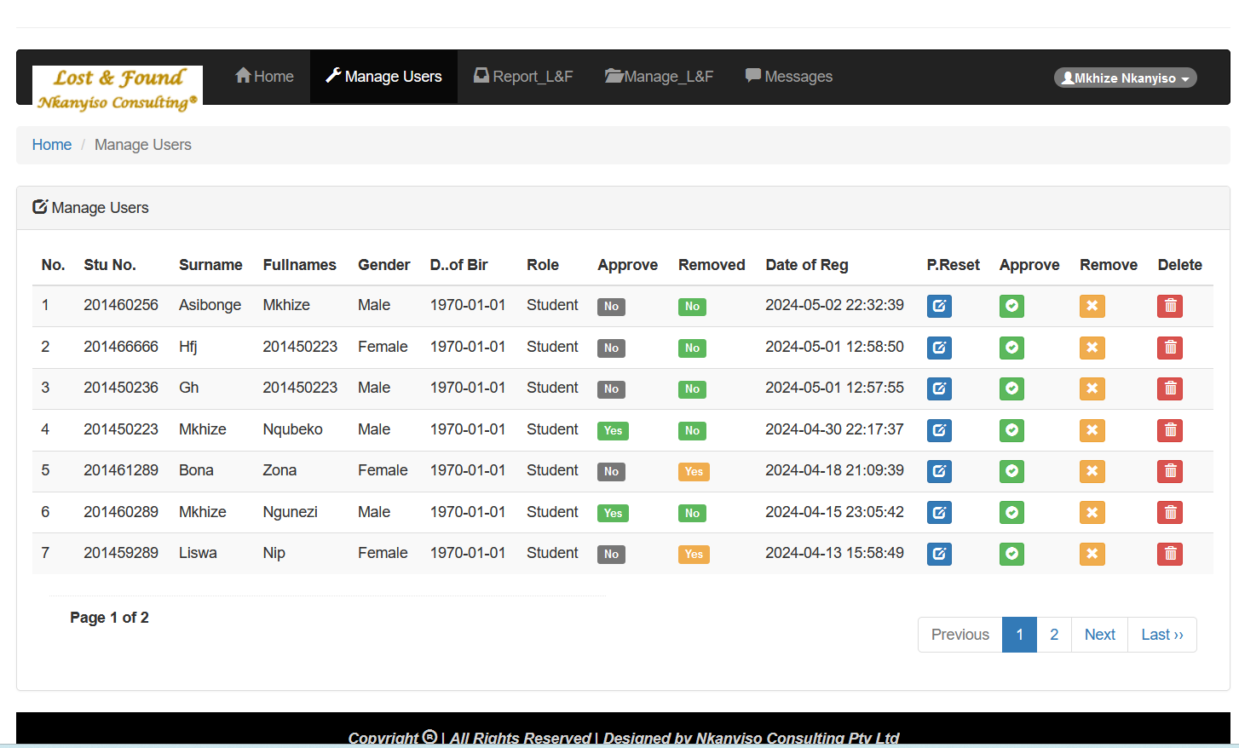

On the **Report_L&F** tab is where you can type the Identifier (*Student Number*) of the found document and select the ***type of that document***, then below there you **select where the owner can come and collect it**

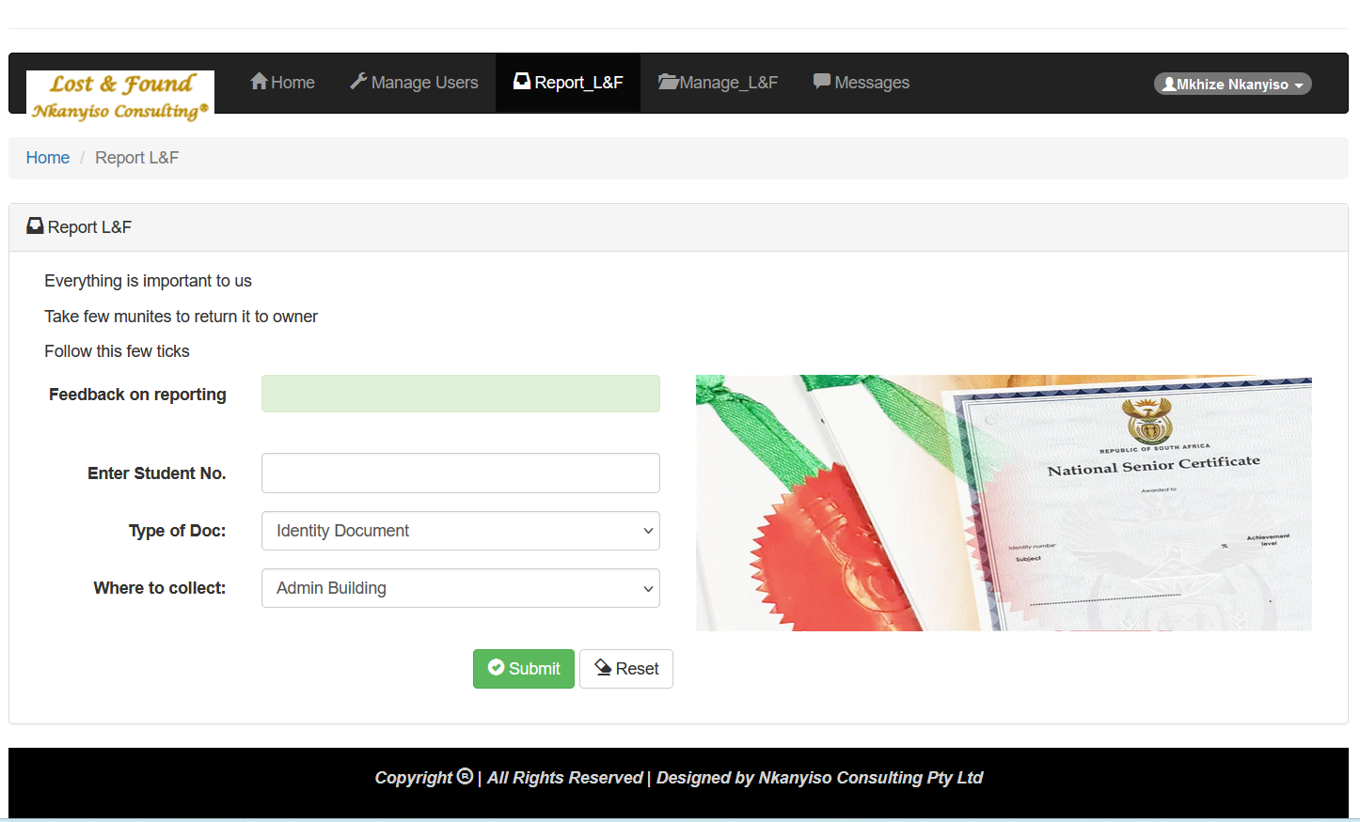

On the **Manage_L&F** tab is where you can view information about documents that have been reported, If the owner of the document come to collect the **Admin** can then change the **Status** by clicking collecting button. The **Admin** can also **Delete** the information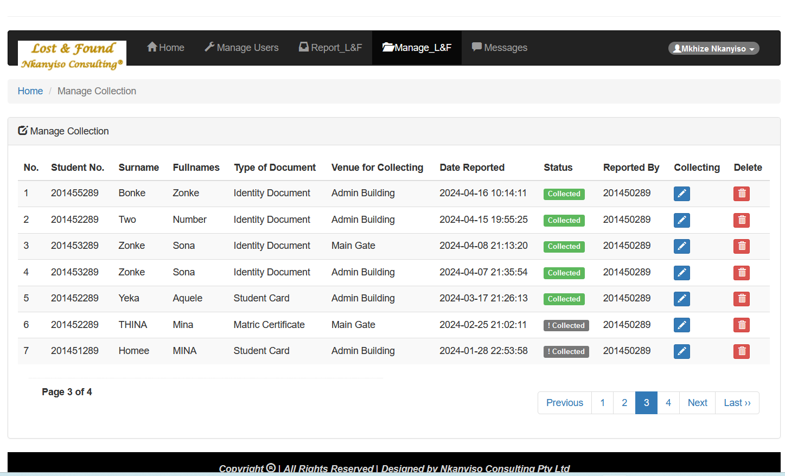

On the **Messages** tab is where you can read all the messages sent by users

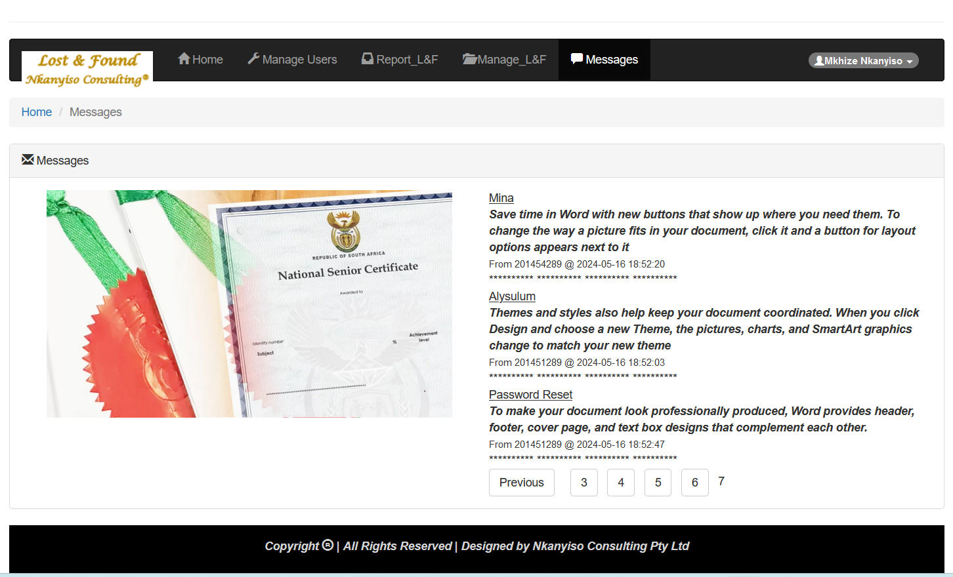On the **Username** you find a dropdown arrow where you can find **Profile** to update the information about yourself, including changing the default password to a more secured one. And also **Log Out** button

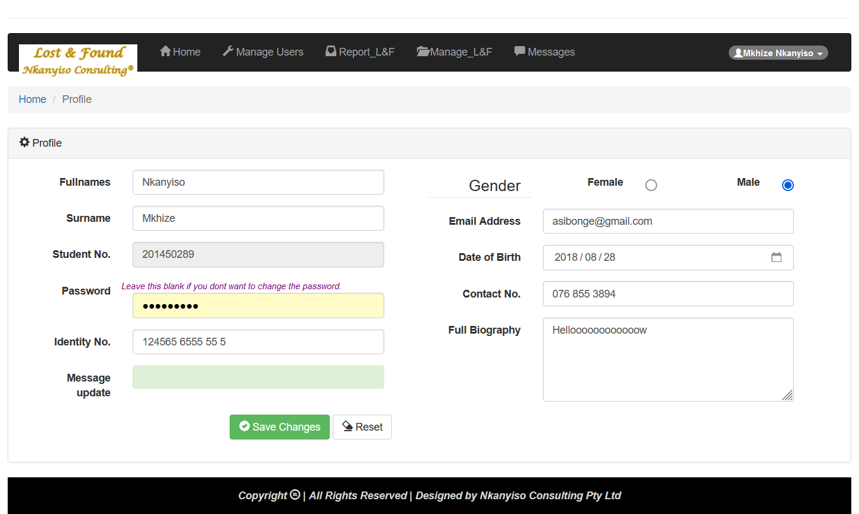

**I thank you**